TUGAS PERTEMUAN 3
PEMROGRAMAN MOBILE DASAR



Disusun oleh:
Rama Pramudya Wibisana 2022320019

PROGRAM STUDI SISTEM INFORMASI
FAKULTAS INFORMATIKA
UNIVERSITAS BINA INSANI
BEKASI
2023
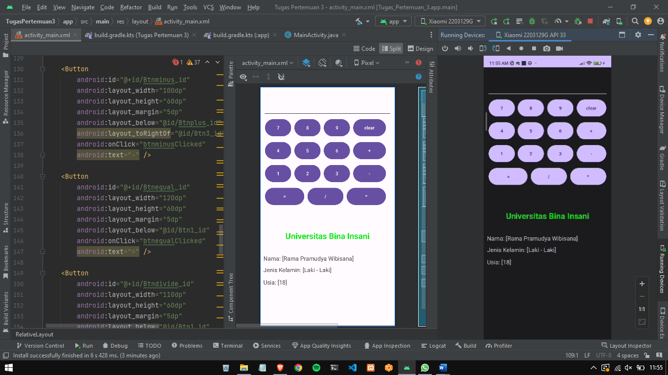

Berikut adalah code pada activity_main.xml

<?xml version="1.0" encoding="utf-8"?>
<RelativeLayout
xmlns:android="http://schemas.android.com/apk/res/android"
xmlns:app="http://schemas.android.com/apk/res-auto"
xmlns:tools="http://schemas.android.com/tools"
android:layout_width="match_parent"
android:layout_height="match_parent"
android:paddingBottom="10dp"
android:paddingLeft="10dp"
android:paddingRight="10dp"
android:paddingTop="10dp"
tools:context=".MainActivity">
<EditText
android:id="@+id/result_id"
android:layout_width="match_parent"
android:layout_height="80dp" />
<Button
android:id="@+id/Btn7_id"
android:layout_width="80dp"
android:layout_height="60dp"
android:layout_below="@id/result_id"
android:layout_margin="5dp"
android:onClick="btn7Clicked"
android:text="7" />

<Button
android:id="@+id/Btn8_id"
android:layout_width="80dp"
android:layout_height="60dp"
android:layout_margin="5dp"
android:layout_below="@id/result_id"
android:layout_toRightOf="@id/Btn7_id"
android:onClick="btn8Clicked"
android:text="8" />
<Button
android:id="@+id/Btn9_id"
android:layout_width="80dp"
android:layout_height="60dp"
android:layout_margin="5dp"
android:layout_below="@id/result_id"
android:layout_toRightOf="@id/Btn8_id"
android:onClick="btn9Clicked"
android:text="9" />
<Button
android:id="@+id/Btnclear_id"
android:layout_width="100dp"
android:layout_height="60dp"
android:layout_margin="5dp"
android:layout_below="@id/result_id"
android:layout_toRightOf="@id/Btn9_id"
android:onClick="btnclearClicked"
android:text="clear" />
<Button
android:id="@+id/Btn4_id"
android:layout_width="80dp"
android:layout_height="60dp"
android:layout_margin="5dp"
android:layout_below="@id/Btn7_id"
android:onClick="btn4Clicked"
android:text="4" />
<Button
android:id="@+id/Btn5_id"
android:layout_width="80dp"
android:layout_height="60dp"
android:layout_below="@id/Btn8_id"
android:layout_marginStart="5dp"
android:layout_marginTop="5dp"
android:layout_marginEnd="5dp"
android:layout_marginBottom="5dp"
android:layout_toRightOf="@id/Btn4_id"
android:onClick="btn5Clicked"
android:text="5" />
<Button
android:id="@+id/Btn6_id"
android:layout_width="80dp"
android:layout_height="60dp"
android:layout_margin="5dp"
android:layout_below="@id/Btn9_id"
android:layout_toRightOf="@id/Btn5_id"
android:onClick="btn6Clicked"
android:text="6" />
<Button
android:id="@+id/Btnplus_id"
android:layout_width="100dp"
android:layout_height="60dp"
android:layout_margin="5dp"
android:layout_below="@id/Btnclear_id"
android:layout_toRightOf="@id/Btn6_id"
android:onClick="btnplusClicked"
android:text="+" />
<Button
android:id="@+id/Btn1_id"
android:layout_width="80dp"
android:layout_height="60dp"
android:layout_margin="5dp"
android:layout_below="@id/Btn4_id"
android:onClick="btn1Clicked"
android:text="1" />
<Button
android:id="@+id/Btn2_id"
android:layout_width="80dp"
android:layout_height="60dp"
android:layout_margin="5dp"
android:layout_below="@id/Btn5_id"
android:layout_toRightOf="@id/Btn1_id"
android:onClick="btn2Clicked"
android:text="2" />
<Button
android:id="@+id/Btn3_id"
android:layout_width="80dp"
android:layout_height="60dp"
android:layout_margin="5dp"
android:layout_below="@id/Btn6_id"
android:layout_toRightOf="@id/Btn2_id"
android:onClick="btn3Clicked"
android:text="3" />
<Button
android:id="@+id/Btnminus_id"
android:layout_width="100dp"
android:layout_height="60dp"
android:layout_margin="5dp"
android:layout_below="@id/Btnplus_id"
android:layout_toRightOf="@id/Btn3_id"
android:onClick="btnminusClicked"
android:text="-" />
<Button
android:id="@+id/Btnequal_id"
android:layout_width="120dp"
android:layout_height="60dp"
android:layout_margin="5dp"
android:layout_below="@id/Btn1_id"
android:onClick="btnequalClicked"
android:text="=" />
<Button
android:id="@+id/Btndivide_id"
android:layout_width="110dp"
android:layout_height="60dp"
android:layout_margin="5dp"
android:layout_below="@id/Btn1_id"
android:layout_toRightOf="@id/Btnequal_id"
android:onClick="btndivideClicked"
android:text="/" />
<Button
android:id="@+id/Btnmultiply_id"
android:layout_width="120dp"
android:layout_height="60dp"
android:layout_below="@id/Btnminus_id"
android:layout_marginStart="5dp"
android:layout_marginTop="5dp"
android:layout_marginEnd="5dp"
android:layout_marginBottom="5dp"
android:layout_toRightOf="@id/Btndivide_id"
android:onClick="btnmultiplyClicked"
android:text="*" />
<TextView
android:layout_width="match_parent"
android:layout_height="wrap_content"
android:layout_below="@id/Btnmultiply_id"
android:layout_marginTop="69dp"
android:gravity="center"
android:text="Universitas Bina Insani"
android:textColor="#0DE816"
android:textSize="25dp"
android:textStyle="bold" />
<TextView
android:layout_width="wrap_content"
android:layout_height="wrap_content"
android:layout_below="@id/Btnmultiply_id"
android:layout_marginTop="143dp"
android:gravity="center"
android:text="Nama: [Rama Pramudya Wibisana]"
android:textSize="18sp" />
<TextView
android:layout_width="wrap_content"
android:layout_height="wrap_content"
android:layout_below="@id/Btnmultiply_id"
android:layout_marginTop="178dp"
android:gravity="center"
android:text="Jenis Kelamin: [Laki - Laki]"
android:textSize="18sp" />

<TextView
android:layout_width="wrap_content"
android:layout_height="wrap_content"
android:layout_below="@id/Btnmultiply_id"
android:layout_marginTop="216dp"
android:gravity="center"
android:text="Usia: [18]"
android:textSize="18sp" />
</RelativeLayout>

Berikut adalah code pada MainActivity.java

package com.rama.tugaspertemuan3;
import androidx.appcompat.app.AppCompatActivity;
import android.os.Bundle;
import android.view.View;
import android.widget.EditText;
public class MainActivity extends AppCompatActivity {
public String str = "";
Character op = 'q';
float i, num, numtemp;
EditText showResult;
@Override
protected void onCreate(Bundle savedInstanceState) {
super.onCreate(savedInstanceState);
setContentView(R.layout.activity_main);
showResult = (EditText) findViewById(R.id.result_id);
}
private void insert(int j) {
str = str + Integer.toString(j);
num = Float.parseFloat(str);
showResult.setText(str);
}
private void calculate() {
if (op == '+')
num = numtemp + num;
else if (op == '-')
num = numtemp - num;
else if (op == '/')
num = numtemp / num;
else if (op == '*')
num = numtemp * num;
showResult.setText(String.valueOf(num));
}
private void calculateNoShow() {
if (op == '+')
num = numtemp + num;
else if (op == '-')
num = numtemp - num;
else if (op == '/')
num = numtemp / num;
else if (op == '*')
num = numtemp * num;
}
private void reset() {
str = "";
op = 'q';
num = 0;
numtemp = 0;
showResult.setText("");
}
private void perform() {
str = "";
calculateNoShow();
numtemp = num;
}
public void btn1Clicked(View v) {
insert(1);
}
public void btn2Clicked(View v) {
insert(2);
}
public void btn3Clicked(View v) {
insert(3);
}
public void btn4Clicked(View v) {
insert(4);
}
public void btn5Clicked(View v) {
insert(5);
}
public void btn6Clicked(View v) {
insert(6);
}
public void btn7Clicked(View v) {
insert(7);
}
public void btn8Clicked(View v) {
insert(8);
}
public void btn9Clicked(View v) {
insert(9);
}
public void btnplusClicked(View v) {
perform();
op = '+';
}
public void btnminusClicked(View v) {
perform();
op = '-';
}
public void btndivideClicked(View v) {
perform();
op = '/';
}
public void btnmultiplyClicked(View v) {
perform();
op = '*';
}
public void btnequalClicked(View v) {
calculate();
}
public void btnclearClicked(View v) {
reset();
}
}

